**Experiment No - 14**

Name: Aayush Yadav

Roll no: 57

Class: SE IT2

Batch: I6

**Program in Java**

**Aim**:- To write a java program for exception handling and

garbage collection.

**Theory**:-

What are Java Exceptions?

* In Java, Exception is an unwanted or unexpected event, which occurs during the execution of a program, i.e. at run time, that disrupts the normal flow of the program’s instructions.
* Exceptions can be caught and handled by the program.
* When an exception occurs within a method, it creates an object. This object is called the exception object.
* It contains information about the exception, such as the name and description of the exception and the state of the program when the exception occurred.
* Types of Exceptions:

Exceptions can be categorized in two ways:

1. Built-in Exceptions

2. User-Defined Exceptions

How Does Garbage Collection in Java work?

* Java garbage collection is an automatic process.
* Automatic garbage collection is the process of looking at heap memory, identifying which objects are in use and which are not, and deleting the unused objects.
* An in-use object, or a referenced object, means that some part of your program still maintains a pointer to that object.
* An unused or unreferenced object is no longer referenced by any part of your program. So the memory used by an unreferenced object can be reclaimed.
* The programmer does not need to mark objects to be deleted explicitly.
* The garbage collection implementation lives in the JVM.

**Program**:-

For exception handling:

public class ExceptionHandlingExample

{

public static void main(String[] args) {

try

{

int num1 = 10;

int num2 = 0;

int result = num1 / num2;

System.out.println("Result: " + result);

}

catch (ArithmeticException e)

{

System.out.println("An error occurred: " + e.getMessage());

}

}

}

For Garbage collection:

public class GarbageCollectionExample {

public static void main(String[] args) {

MyClass obj1 = new MyClass();

obj1 = null;

System.gc();

System.out.println("Garbage collection may have been triggered.");

}

}

class MyClass {

@Override

protected void finalize() {

System.out.println("Object is being reclaimed by the garbage collector.");

}

}

**Output**:-

For exception handling:

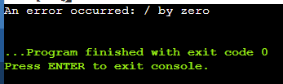

For Garbage collection:

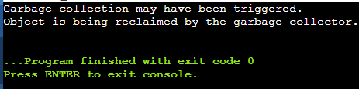

Learners Outcome:- Learners will be able to understand

the concept of exception handling

and garbage collection.

Conclusion:- We have successfully implemented java

program for exception handling and

garbage collection.